First student

The circus performance is made up of different acts with acrobats, entertainers, clowns, hoopers, dancers, magicians, and trained animals. The way I became acquainted with this art, was due to my mom taking me to my first circus performance when I was 8 years old, it was a live performance. Going to see this kind of performance act became a family tradition, everyone would get hyped every time we heard there would be one in our city. At the time I was a child, so observing the acrobats perform lighted my eyes with joy and emotion.
The most permanent emotional memory I have of a circus, happened at around when I was 12 years old, it was Mother’s Day and the clowns along with dancers and singers performed a story-like act, of a mom that is poor and cannot feed her children. I remember the dance choreography was melancholic and together with the song, it was an “emotional bomb”, the performance made me feel very appreciated to have a mom that loves me and I couldn't live without, now that I’m older, she brings that story very often, every time I “act up” in front of her, oftentimes in front of strangers or family as to embarrass me of being such a crybaby.
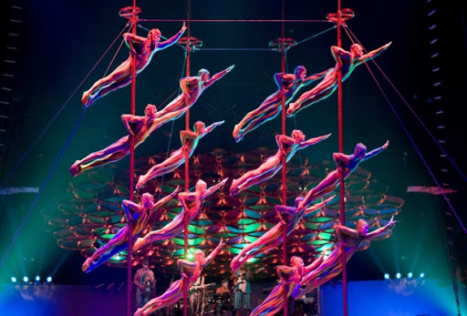
Response
I agree with this post. Circus performance often comprises of different acts as indicated. One becomes acquainted with such performance by physical attendance. The activities which take place are often fascinating; they have a long-lasting effect and hence make up lifetime memories. That being said, it's usually a recreational activity, and hence one feels good, all piled up pressure in one’s body is often blown out. Bonds are often made stronger as people socialize more.

Second student

My most memorable performing arts experience I had was at Disney World in the summer of 2016. I was immersed in theatrics, live performances, street dancing, singing and impressive fire work displays during my visit. One of the best experiences was an Epcot dinner show in the Germany section. It reminded me of another beer garden I had visited in Fredericksburg as a kid. The lively environment, the music onstage, audience interaction and the food all made for a perfect evening. The pictures uploaded show some of the musicians dressed in their lederhosen on stage and performing a song using various instruments and bells. The beer garden experience and all the fun that Disney offers made me feel like a kid again. Despite hot weather, long lines, tons of people, and expensive merchandise, I didn’t come across anyone in a bad mood. Disney was a wonderful step away from reality.
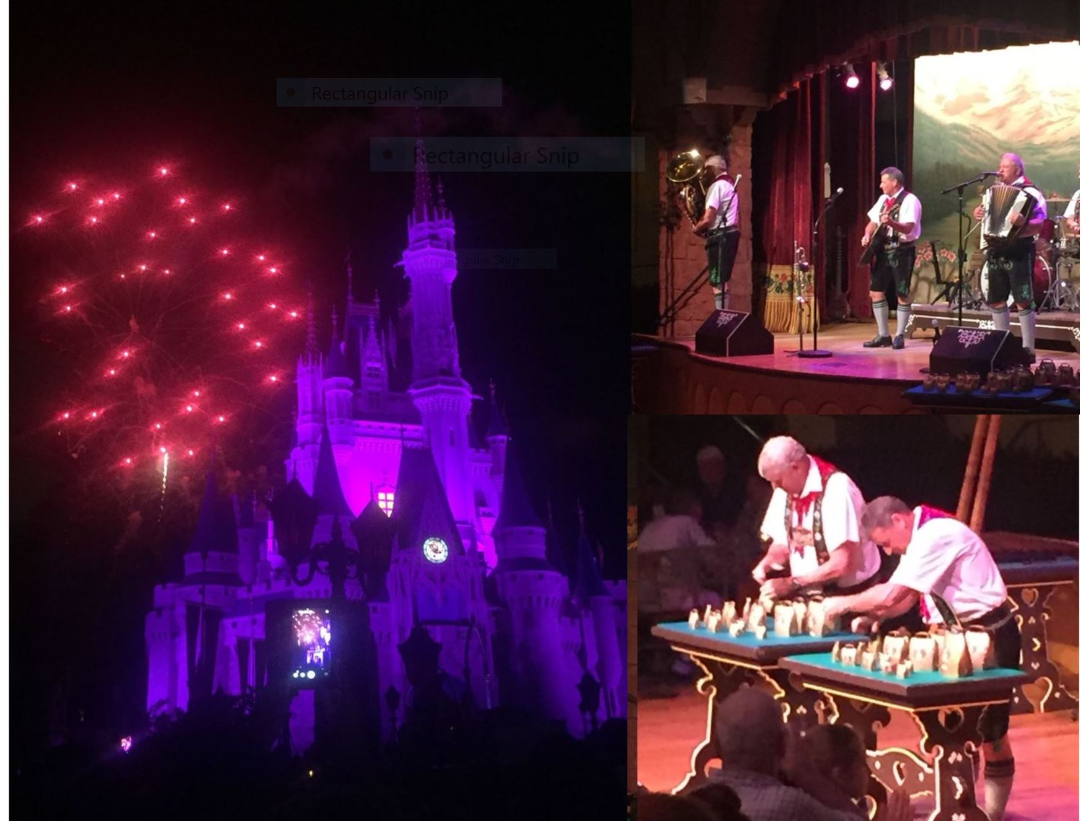
Response
I agree with this post. Disney organizes the most beautiful performing arts. Though people may have a different view of their art, it can be seen as a learning scene in a way. For example, Different cultures are often displayed, like the Germany dinner. Additionally, it's usually a recreational activity and helps people socialize more and build up long-lasting memories. Lifetime bonds are made substantial, and people blow away stress which may have built up while in their usual environments.

